CUBEMX Standalone for STM32CubeIDE
  - Seth Ricks

Previous versions of the STM32 cube IDE had a built-in GUI for the pin layout of the STM board. With version 2.0.0, it is different. If you try to click on your .ioc file in the project explorer, you will see a text file instead of the GUI. You will have to download a separate program for this GUI to work.
You can find the download for CUBEMX here. Make sure to download the appropriate version for your operating system.
Accept all the default installation options and the installation location.
When completed successfully, you can click on your .ioc file and it will run CUBEMX in a separate process. It looks just as it did in previous versions.
Before you start making changes, make sure that you are in the correct project location by pressing project manager->project. The project location should be the same as your project in the CubeIDE, and your Toolchain should be STM32CubeIDE. If this is not true, then the code will not save and generate properly.

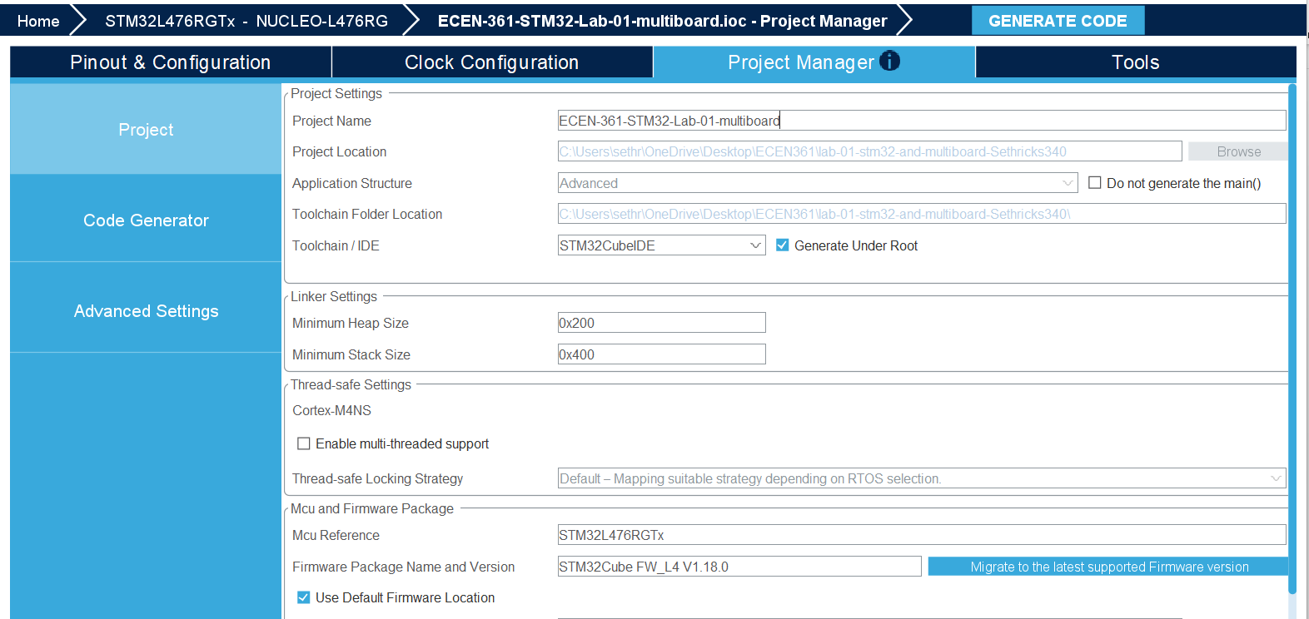

IMPORTANT: When you are done editing the GUI, you must manually generate code. This is different from before, where the CubeIDE set a flag to notify you to generate code. You can do this by pressing the GENERATE CODE button shown below. If you don’t do this, your changes will not be saved to main.h and other initialization code files, and your changes will not be realized.

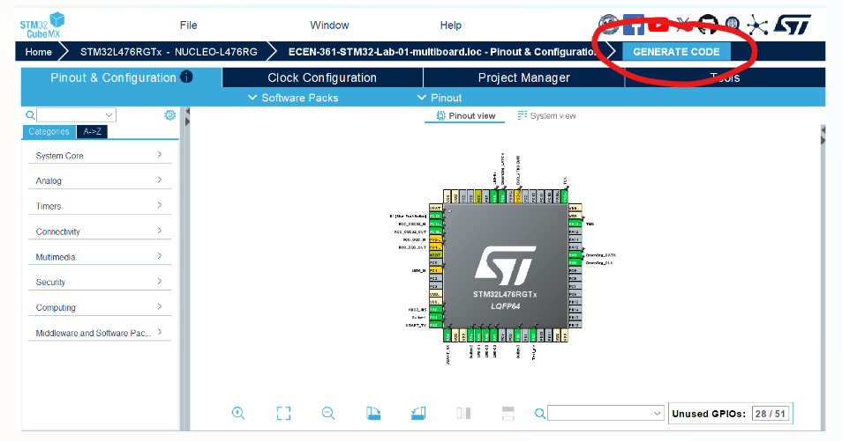

After you have generated your code, you can return to CubeIDE to continue with your project as before. The changes you made to the Pinout GUI can be seen in your new code.

